(Approx. 2,180 words)

Software Review: Acronis True Image Home 2012
By Mark Mattson, Editor, Computer Users of Erie, PA
March 2012 issue, Horizons
www.cuerie.com
cuerie1 (at) verizon.net

One never knows when disaster will strike. It could come anywhere, anytime, from any direction. And this is no less true when it comes to disaster striking your computer system. Just in the last month, I found out how true this is. I was preparing to start working on last month's newsletter and, when I started up my second computer (the one that does all my digital photo and newsletter work), I was faced with the dreaded 'click of Death' from the boot hard drive inside the box.

Naturally, it had been over a month since the last backup on this system, and all my document templates and such were captive on a dying drive. Holding my breath, I gave the drive controller board a blast of component cooler, and it got the drive to boot. I then transferred all vital files from the dying drive as well as the second drive to my NAS system, and prepared for disaster recovery.

I had been running evaluation tests on Acronis True Image Home 2012 prior to this failure, so I had a copy available to use to clone the entire drive to the second drive in the machine. This would allow me to keep working until I could purchase a new boot drive for this system.

I installed the software onto the bad drive, and ran the drive clone feature, which imaged the original boot drive to the other one. When it was complete, I pulled the failing drive (good now for a paperweight), and fired up the machine again.

Success! The image worked, and the computer was once again up and running.

What could have been a disaster of major proportions was solved by the use of a single, inexpensive program. Without it, I would have faced at least a week of reloading all the apps on this machine, not to mention trying to find workable copies of newsletter templates, including the actual files of the published issues. I most likely would have lost a majority of the 2011 files. But the image had them all. The biggest timesaver was the preservation of my Lightroom catalog...that alone would take about three days to recreate from the NAS box. In a matter of minutes, it was restored to the new drive
and was intact.

Acronis True Image Home 2012 is the latest release of their most popular backup solution for home users. Introduced originally in 2002, it then could produce disk images on recordable DVDs and other external recordable media, for use in restoring your system. As the years went by, the releases added more and more functionality, until the current version, which incorporates all the features of previous versions, and also gives you the online backup option debuted in True Image Home 2010. True Image Home 2011 also added support for Windows 7, as well as a new user interface, among other
enhancements.

Features to make life easier
The feature set of True Image Home is able to handle most recovery backup task you can think of. You may image your entire disk at once, or use it to make file level backups at any time you need them. No matter what your needs, there's a function built-in to handle it.

- Patented disk imaging and cloning software ensures that every bit of your data is backed up, and able to be restored to its original condition in minutes. No need to reinstall your software and OS (Operating System) again!
- The new File Synchronization functionality allows you to keep files in sync between all your computers, with no effort on your part.
- Run your backups on your schedule, not the program's. Smart scheduling allows you to set the times and days when the backups will run. And the new Set & Forget feature lets you set up your schedules once, then it does the work of running them for you. No more forgetting to run a backup.
- Try & Decide allows you to install a new piece of software that you're not entirely sure of (as far as it not being a bug factory), and allows you to 'roll back' your system safely to before you installed it. No more dangers of bad things corrupting your computer. Good also for surfing somewhat iffy websites...it will help recover from those dangers as well, if you encounter any.
- Nonstop Backup makes incremental backups of your data as you work, around the clock. You can now restore to any given point in time.
- If you back up to large external hard drives that may not be supported your OS not a problem. True Image Home will support 2TB and larger drives with ease.
- Have a NAS attached to your home network? No problem. True Image will detect it, and set it up as a backup location for you.
- If you need to recover a single file or folder, or several, you can mount your backup image and use it to get what you need. No need to restore an entire disk for just a few missing files or folders.
- If you have sensitive data that needs protection, not a problem...there's built-in encryption for you, waiting to be put to use .
- Flexible backup options allow you to backup how you want...full image, file level backups, or incremental / differential backups. And the backup can run while you work...no need to shut down and boot into a backup only running environment.
- If you need off-site storage for your backups, there is an option available for you as well. Acronis True Image Online allows you to back up your files to their secure data center, giving you peace of mind that your data will be available anywhere you may be.

One feature to beware of, however, is the Secure Zone. It makes a hidden partition on the drive you are backing up, to store your backup files in. This WAS a useful function in the days when external drives weren't available, or too expensive to justify the cost. But the real danger is, if the drive should fail completely, as mine did, all your data is gone....because it's on the dead drive with your live partition. DO NOT use the Secure Zone feature.

Installation
When you purchase your copy of True Image Home 2012, you receive it via direct download to your machine. An email with your purchase details and serial key is then sent to you to complete your installation. Simply run the executable file as you normally would, and answer the required setup questions. If you choose to use the defaults, installation takes only a matter of minutes.

Unlike some other software packages, the license key is valid for only one machine. If you have multiple machines you need to image, you need to purchase licenses for each machine. More on this later...as well as a way to get them for a much lower price.

In my case, installation only took about 5 minutes. I chose all defaults, and it went without a hitch. Once installed, double click the icon to launch the program.

Operation
When you first open the application, you are greeted with a generic tasks window, which gives you some basic information on how to perform a backup, restore, or sync. It might not be a bad idea to review these hints, as well as look at the online materials at the Acronis website to get you started.

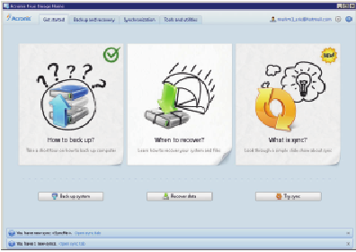

You want to be at the backup functions, so click on the Backup and recover tab at the top to open the backup functions dialog. Once there, click on the Drive and partition
backup icon in the menu bar, and you will be presented with the following window:

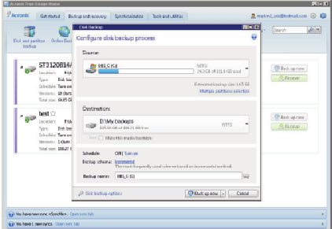

Select your source and destination drives here. You may switch between Drive and Partition views, in case you have a multiplication drive...you can select only the partition you need imaged, instead of doing the entire drive.

You also need to select the backup style as well...whether it be full, incremental, or differential. There are also a multitude of options available to let you tweak the backup to your requirements, giving you the freedom to choose how the program works...and the peace of mind that it does what you need it to do for you.

There is also an option to set the options you choose as defaults, so you don't need to reselect them with each new backup job you create.

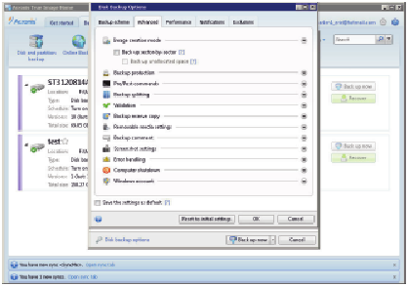

Once you have the parameters of your backup job set, click OK to get back to the main backup window, and click Backup Now. That's all there is to it. The process will start
by enumerating your files needing backing up, and then starts the image process.

Depending on the size of your data and speed of your drives and interface (if USB) or media (if going to CD or DVD), this can take some time to accomplish.

As an example, my first test backup was sized around 160GB, and took over an hour to complete, using an external USB 2.0 drive. As this is a somewhat antique system (1.3 GHz CPU and 1GB memory), the throughput is somewhat slower than an up-to-date system. As with anything, your results may vary...but an image based backup will take much less time to complete than a filebyfile backup method.

If you just need to back up a set of files or folders, that can be done without doing an entire drive image. On the backup window, click on the Other backups icon, and choose File backup. This window will appear:

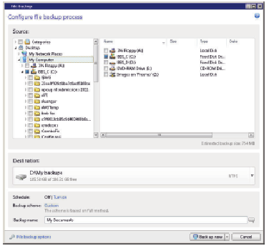

which will allow you to select the files and folders you wish to back up. When completed (and you've chosen your destination drive), simply click on the Backup now button once again, and your selected items will be backed up.

Pricing and availability
Acronis True Image Home 2012 is available directly from the developer's website, www.acronis.com. A single PC license is priced at $49.99 as of this writing. If you need a 3 PC license, it will run you $79.99. Delivery is via electronic download. There is also a 30day free trial download available, if you want to try before buying.

However, there IS an alternative available exclusively for user group members. A single copy license is available from Gene Barlow at User Group Relations (www.ugr.com) for
only $25. This is the full, noncrippled program...no features are missing. He has made arrangements with Acronis for this special user group member pricing, and it is available to you now...but you MUST order from Gene's website. If you should need the three license package, he has it available as the Family Pack for $60, a savings of $20 from the Acronis store price. And as an additional bonus, Gene will ship you a physical CD with your program on it for the same price, plus shipping and handling. Ideal if you don't have a broadband connection (the download is over 200MB, which can take some time on slow connections).

Even more good things come when you purchase through Gene. First, he provides better support for the product than you'd usually get from Acronis as far as operation goes. He will provide you with a copy of his Starter Guide on the CD, or a link address with your serial number. This 21 page document has stepbystep instructions on installing and using the product the best way possible to get you off on the right foot.

Another bonus is technical support. Acronis only gives you 30 days free support from the date you purchase. Gene will give you support as long as you own and use the product, at no additional charge. With the price of tech support companies are charging now, this is a highly attractive offer, one that can save you a lot of your hardearned money. And this all comes with a 50% savings from the manufacturer's pricing. A bargain that actually works for you!

Final thoughts
I have been using a competitive product to True Image for many years, and thought I had found the only backup application I would ever need. But recently it has become
more unstable, and not getting any better with subsequent versions (I was beta testing the product, and saw what was happening). I set out to find a new solution, and had heard good things about True Image.

I'm glad I decided to take the plunge and make the switch. The time savings alone from the failure of the hard drive in this machine, and the recovery that was provided by this product would make up ANY price they decided to charge for it. But for the price, it is a definite musthave for your toolkit, if you need to ensure reliable and accurate data preservation.

Don't pass this one up. You'll be glad you have it at some point. Hard drives DO fail...and usually at the time you need them most.

